**Overview:**

               The sales department in a company that sales tech products, needs their data to be analyzed. For their sales team to be able to take the right decisions based on the trends of the products sales and analyze the customer behavior.

**Inputs:**

* You were given a dataset (Kindly check the mail attachment) showing the sales over 2 years (2008 and 2009) for a different products and customer in different countries.
* Also you were given a forecast **on the level of brand and country for the total year of 2009.**

                The schema of the data is shown as below:

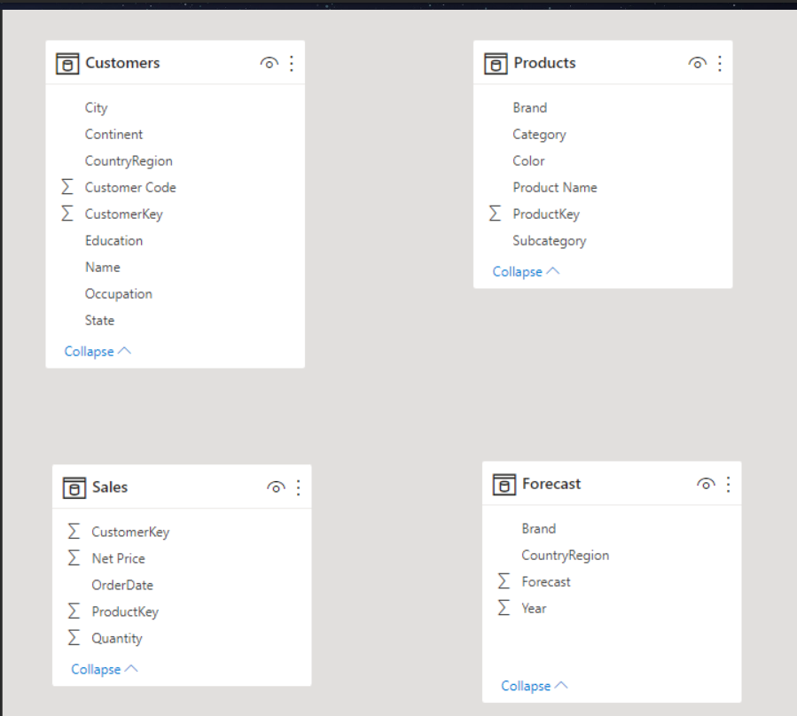

**Requirements:**

You are asked to use the dataset to do the following requirements using Power BI:

1. **Connecting the Model**
   1. Connect the tables with each other with the right relationship taking care of the different granularity between Sales and Forecast tables.
   2. Create a date table and connect it with both Sales and Forecast.
   3. Fixing the customer errors.

1. **Analyzing Sales**
   1. Show the total sales in dollars in different granularity.
   2. Compare the sales in dollars between 2009 and 2008 (Using Dax formula).
   3. Show the Top 10 products and its share from the total sales in dollars.
   4. Compare the forecast of 2009 with the actuals.
   5. Show the top customer(Regarding the amount they purchase) behavior & the products they buy across the year span.

 Sales team should be able to filter the previous requirements by country & State.

1. **Visualization:**

* This is should be one page dashboard
* Choose the right chart type that best represent each requirement.
* Make sure to place the charts in the dashboard in the best way for the user to be able to get the insights needed.
* Add drill down and other visualization features if needed.
* You can add any extra charts/widgets to the dashboard to make it more informative.